VLSI Project: Elevator Control System

Part 6

Name: Prajwal Paul & Khoa Diep

ktd170030

psp170030

EECT / CE 6325

Instructor: Prof. Sechen

Date: 12/06/2023

**Design Process**

* Tradeoffs
  + Due to the limitations of no metal2 and limited amounts of horizontal poly, we decided to wire almost all of the gates with metal1 (only 2 are wired with short horizontal polys). The layout was designed with a greedy method from left to right. For each gate, we do not care about future wires and only care about the wires to itself and past gates. We chose this method because it was the simplest layout to design by hand, with the tradeoff of optimal size.
  + When designing the layout of each gate, we chose to keep the pin pitch of every gate at 0.26 um to keep it simple to implement for future gates. However, we could have decreased the pin pitch to the optimal size after implementing our final gate (DFF) in order to decrease the width of the gates.
  + The design after Project 1, after synthesizing, had only around 100 cells. Thus during project 2, we had to complicate the design by increasing the cells of the synthesized verilog to a little over 6000 cells in order to meet the project requirements.
* Function of our Design
  + The first situation is the assigning of requested floors to the two elevators. First, we give priority to elevator 1, which takes the request and assigns it as its final floor and each of the flags as the request is taken. Next, if elevator 1 is busy, the request is sent to elevator 2 and the same actions as completed for this, which are the request taken flag and the floor is assigned as the final floor for this elevator. The final situation is when both elevators are busy. Then the request is held on until the first elevator gets free. The next states to explain is the reset and emergency function. The reset function case reset the elevator system. This command is used as a “new command is given” method and resets the arrived at destination and emergency signals, while also setting the current floor where the elevator is at to the output. The emergency function checks if the emergency input is activated then forces the doors open by the arrived variable, turns on the signal and stops elevator motion. The last situation is the checking and motion of the elevator by checking the relationship between the destination floor and current floor. The first stage is when the targeted floor is above the current floor and there is no emergency signal. In this stage, the direction is set to 1 meaning going up and the elevator moves up one level for each clock cycle, which is done by bit shifting 1 bit to the left for each cycle. The arrived at destination signal is kept off during movement and as the elevator is moving to a targeted floor, the busy status flag is turned on. Also, as a precaution, the emergency signal is turned off as this check has already been completed. The next case is when the targeted floor is below the current elevator floor. Here, the direction is set to 2 meaning going down and the elevator goes down a floor per clock cycle by bit shifting the 1 bit to the right each cycle. The arrived at destination signal is kept off during movement here as well and as the elevator is moving to a targeted floor, the busy status flag is turned on. Also, as a precaution, the emergency signal is turned off as this check has already been completed. The final case is when the elevator has arrived at the targeted floor, where the arriving signal is turned on to open the doors and the direction is set to 0 which means no movement. Here, we free up the busy status for the elevator and show that the requested task flag that was turned off is completed. The only communication needed between the two elevators is done in the first situation. The second and third situations are analogous and are interchangeable. This is done by manipulating each elevator’s input and output in its related function. For example, elevator 2’s movements are done in its own if else loop while elevator 1’s is done another. Also, each elevator’s reset flags are controlled separately.
* Testing Process
  + For the entire elevator design, we tested our design by creating a testbench and documenting the desired output. After creating the design using Verilog, we tested that design with the testbench. Afterwards, we created a synthesized verilog file, and tested that file with the same testbench. The outputs of both should be the same.
  + While testing each gate, we used Cadence Tools (such as DRC, LVS, and PrimeLib) in order to make sure that the layout and schematic matches the desired functionality. If any of these failed, we had to check where the error occurred and fix the according mistake. For example, when designing our DFF, we could not pass the LVS stage and after debugging and checking the layout and schematic, we realized we forgot to implement a part of the TRI-STATE NAND of the DFF and fixed the problem once identified.
* Worst Case Delay -196 ns
  + We found the worst case delay using PrimeTime. Specifically, we increased the clock period in “variables1” in the PrimeTime directory until we got a positive slack.

**Primelib for DFF**

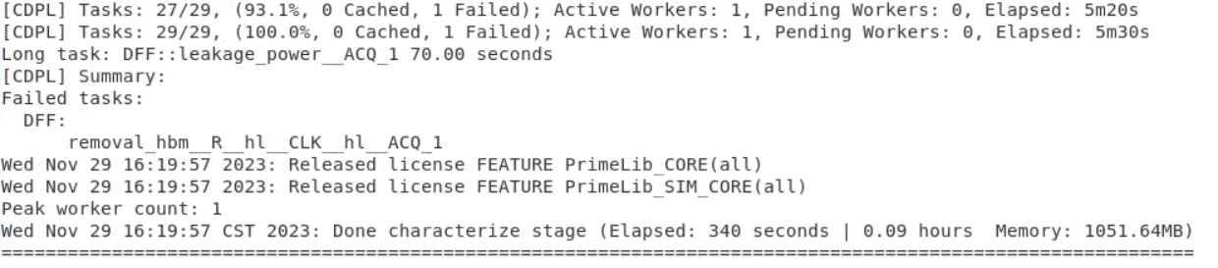

Characterization due to “removal_hbm__R__hl__CLK__hl__ACQ_1”. However the Model step was successful.

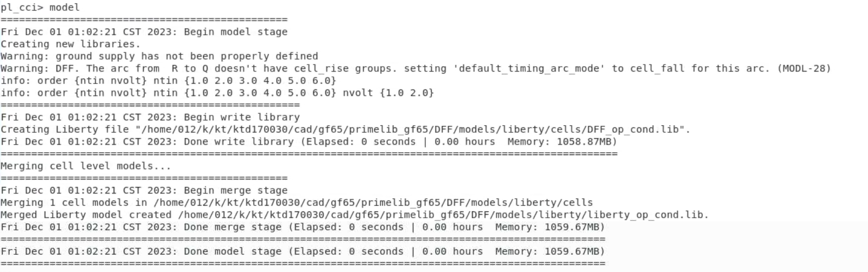

**Filler Cell Layout**

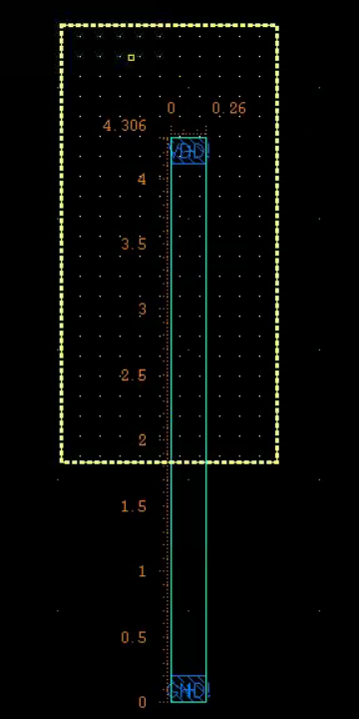

**Filler Cell DRC**

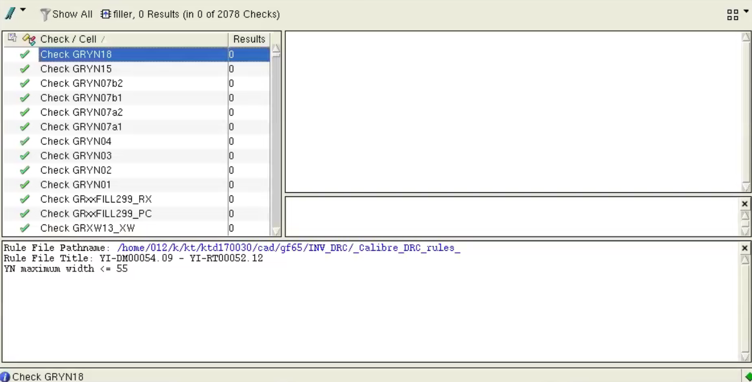

**Final Cell Report**

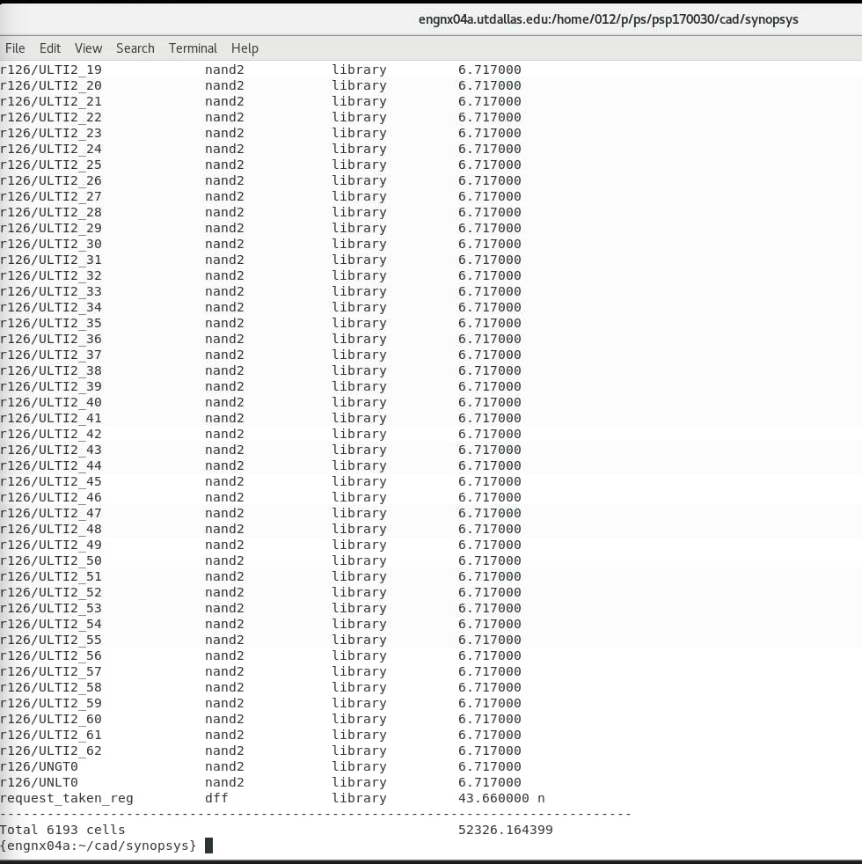

**Innovus Completed**

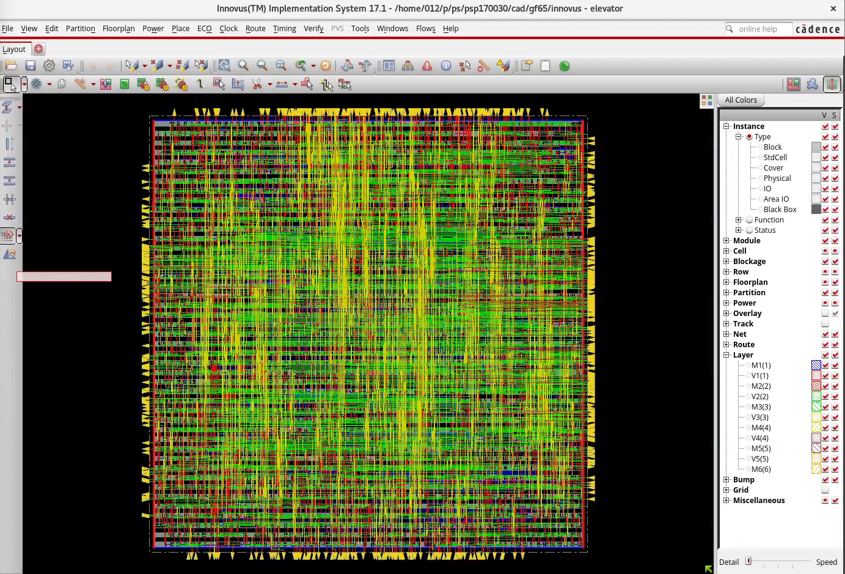

**Imported Elevator Layout from new design library using Innovus**

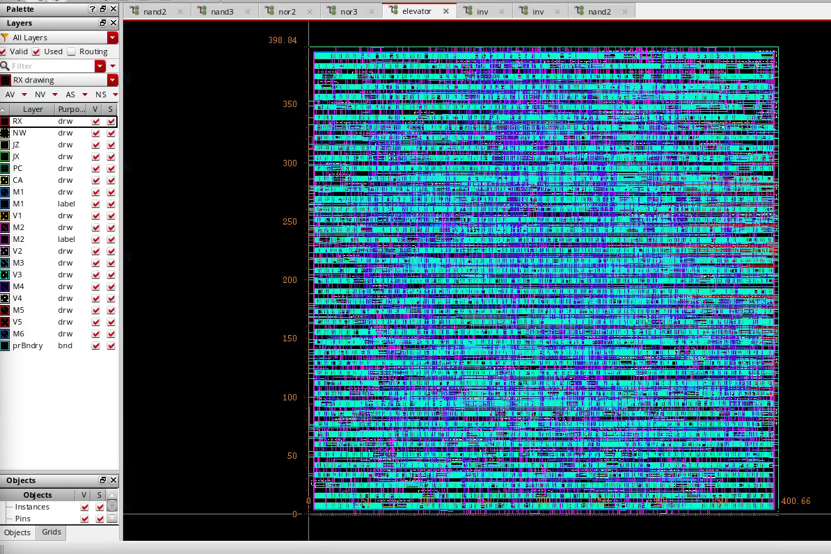

**Mapped Code Waveform**

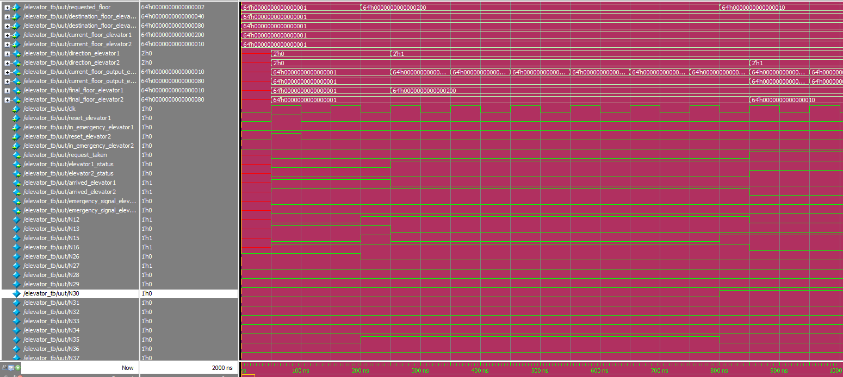

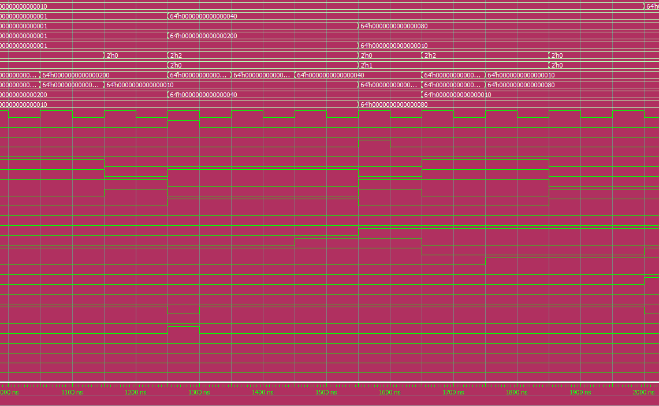

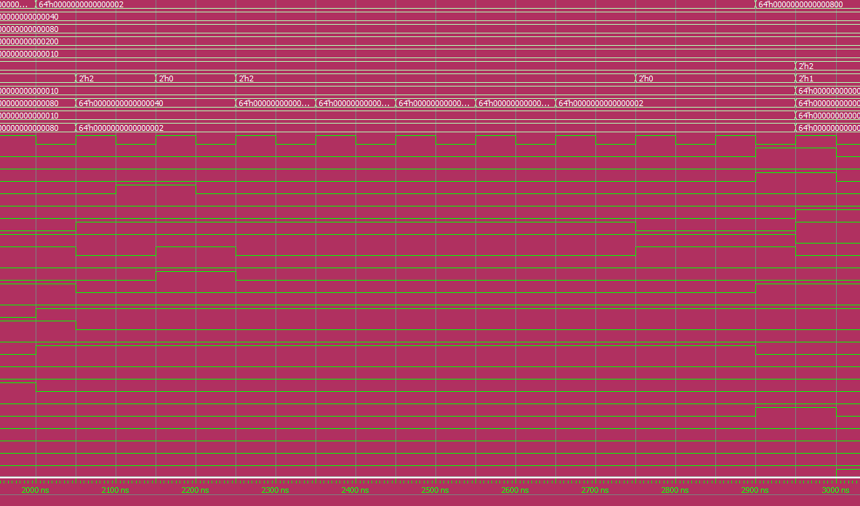

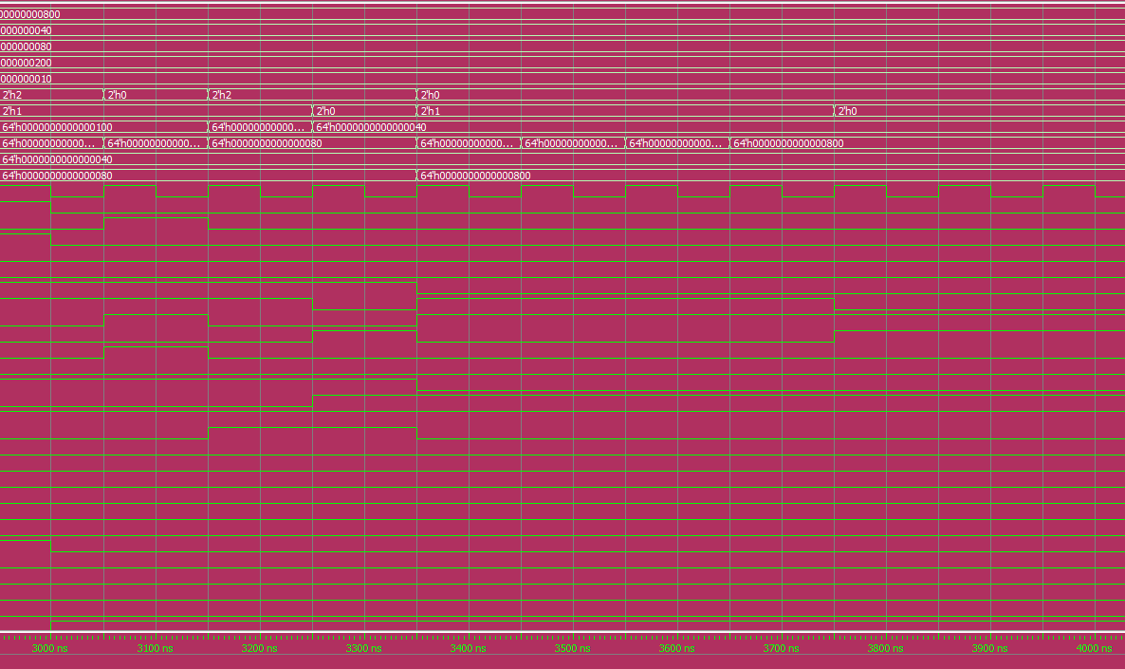

Above are the screenshots of the synthesized verilog elevator module, that was used for the gate connections described in the final layout, from report2.

**DRC Report**

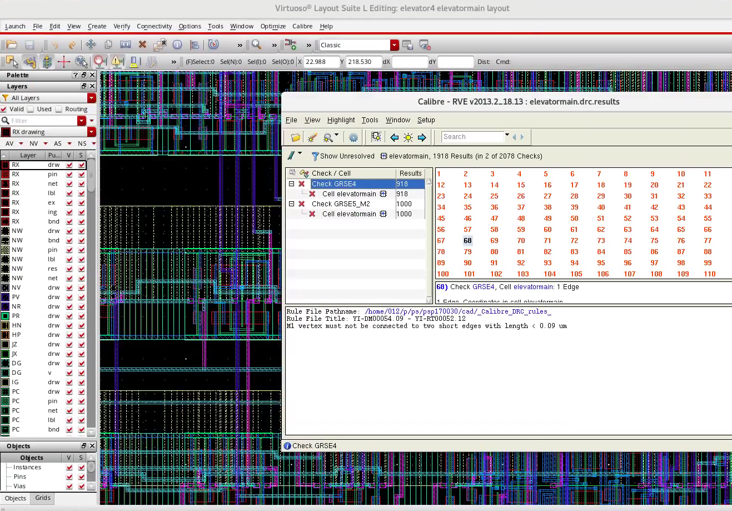

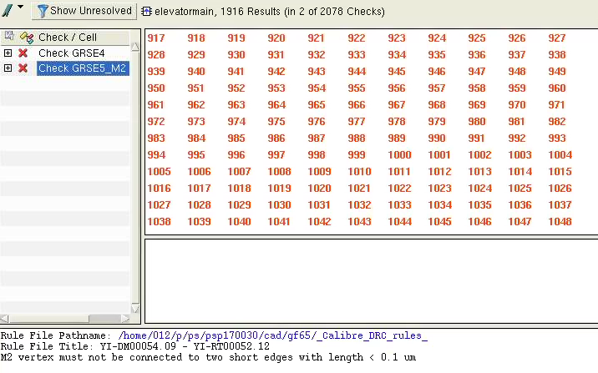

Looking at the above DRC report, we can see that there are two types of errors, totaling up to about 1900 errors. Upon review of these errors, both are related to the pins' interaction with the various routing. There are some small edges and lines that do not line up and there isn't enough area due to this. Due to time, we are unable to correct them all.

**LVS Report**

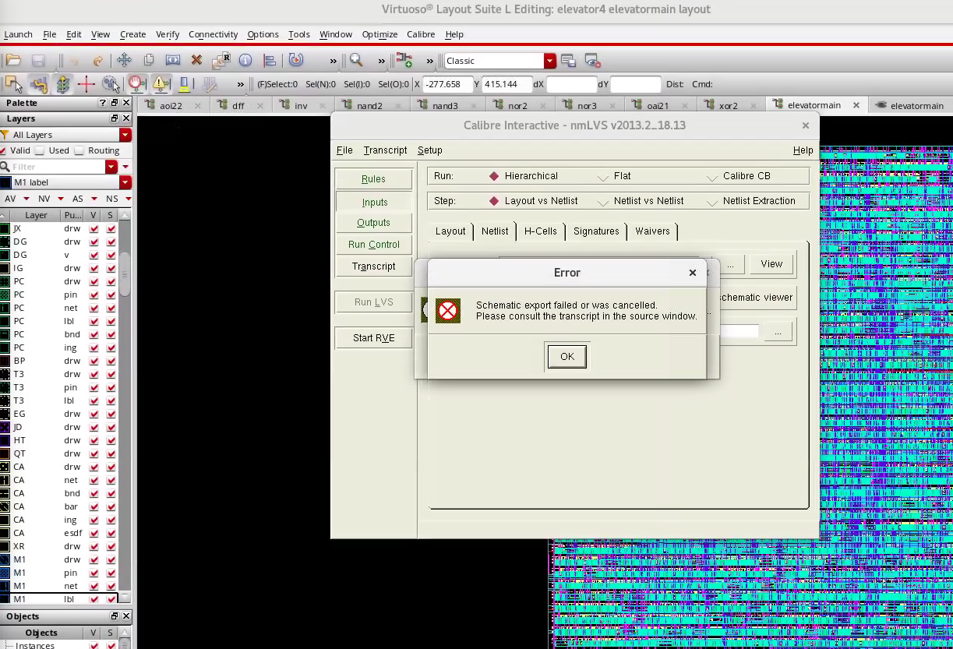

Regarding the LVS check, we had issues running the actual check. We think that this is because there are various versions of the layout, schematic and symbol view that are causing problems with the execution. Due to time, we were unable to correct this.

**Primetime Script Run**

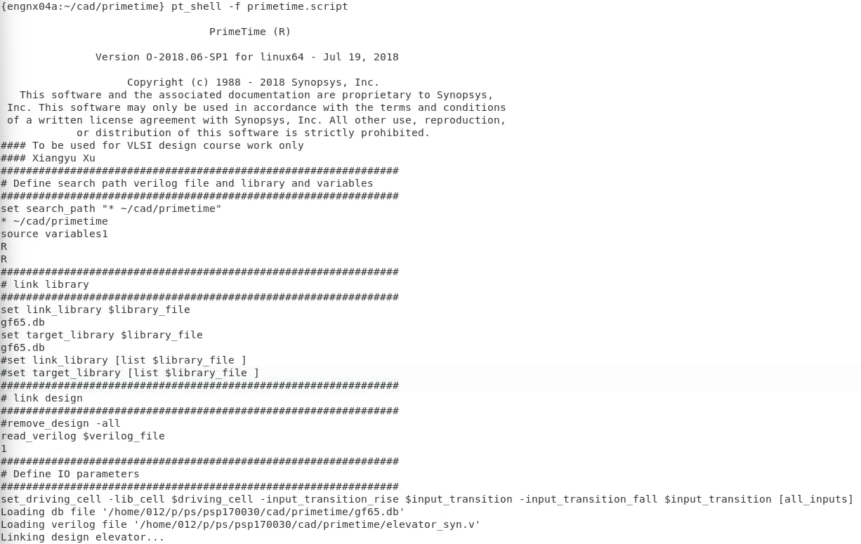

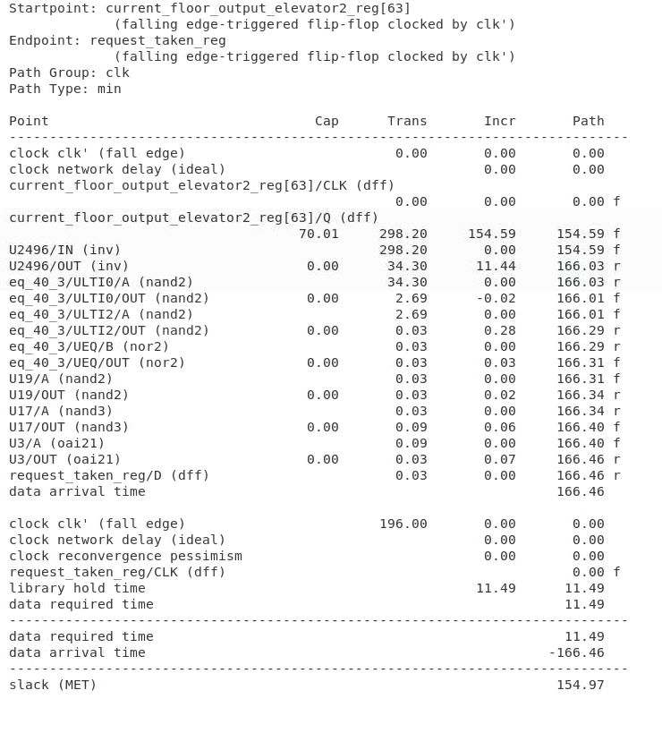

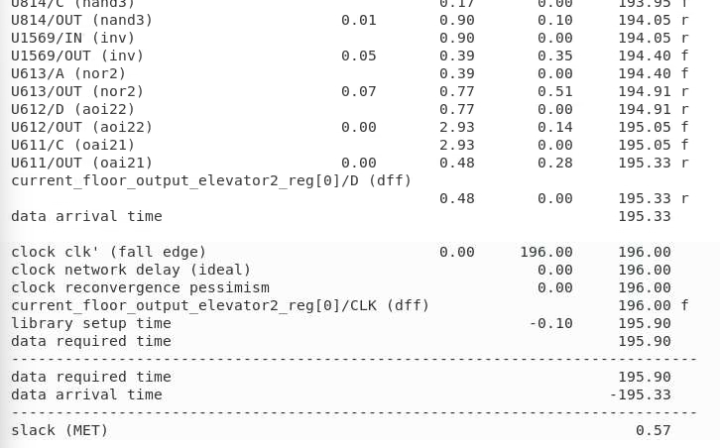

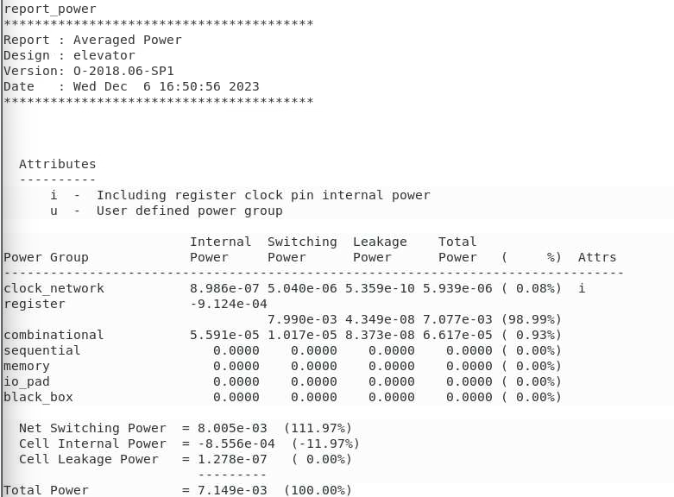

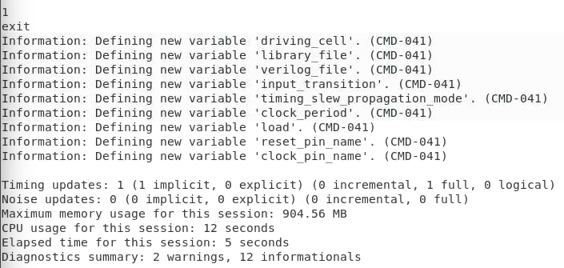

Above is the report from the primetime run. We had to edit the variables1 file and the primetime.script to correctly generate a report.

**Final Design Symbol View**

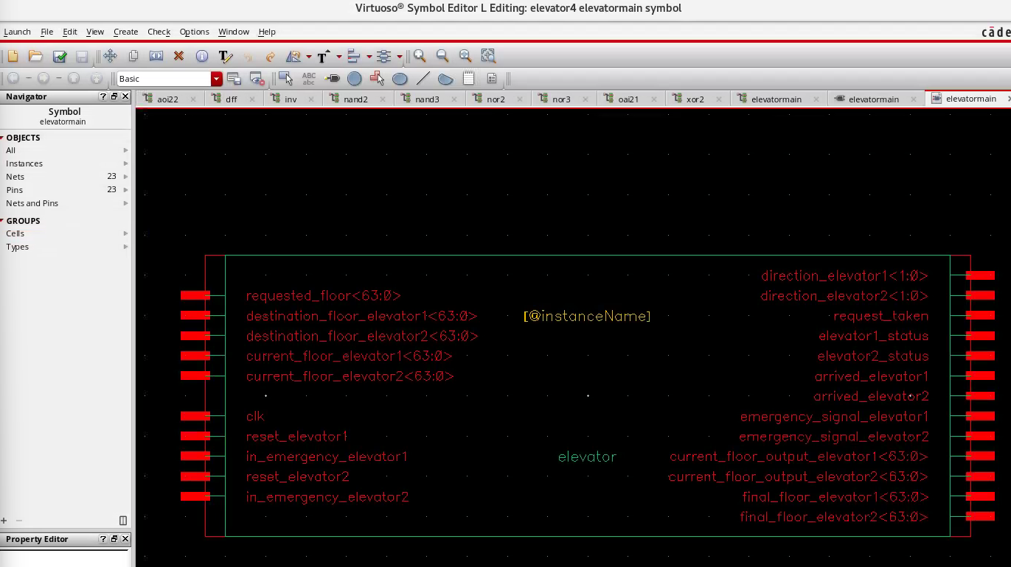

**Final Design Schematic View**

